**Before each task, make sure you run the server first by going to the correct directory and running *rails server***

1. Test Homepage

You should see this load:

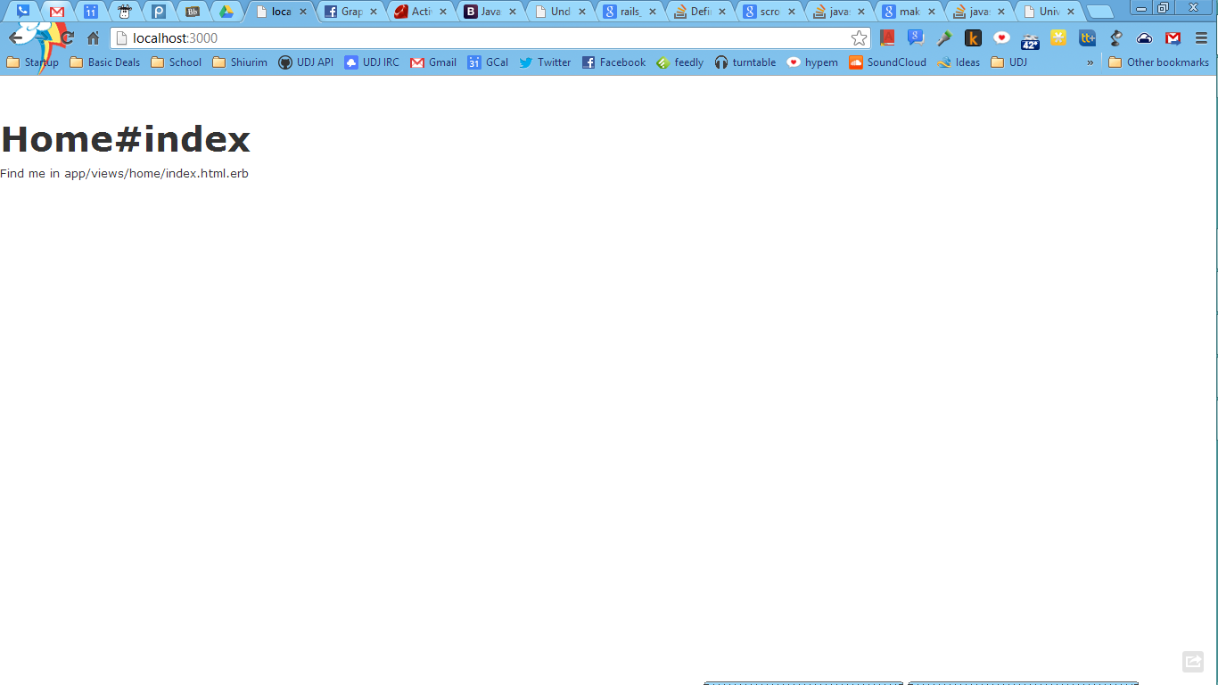

1. Test Colleges page by going to localhost:3000/colleges

You should see this load:

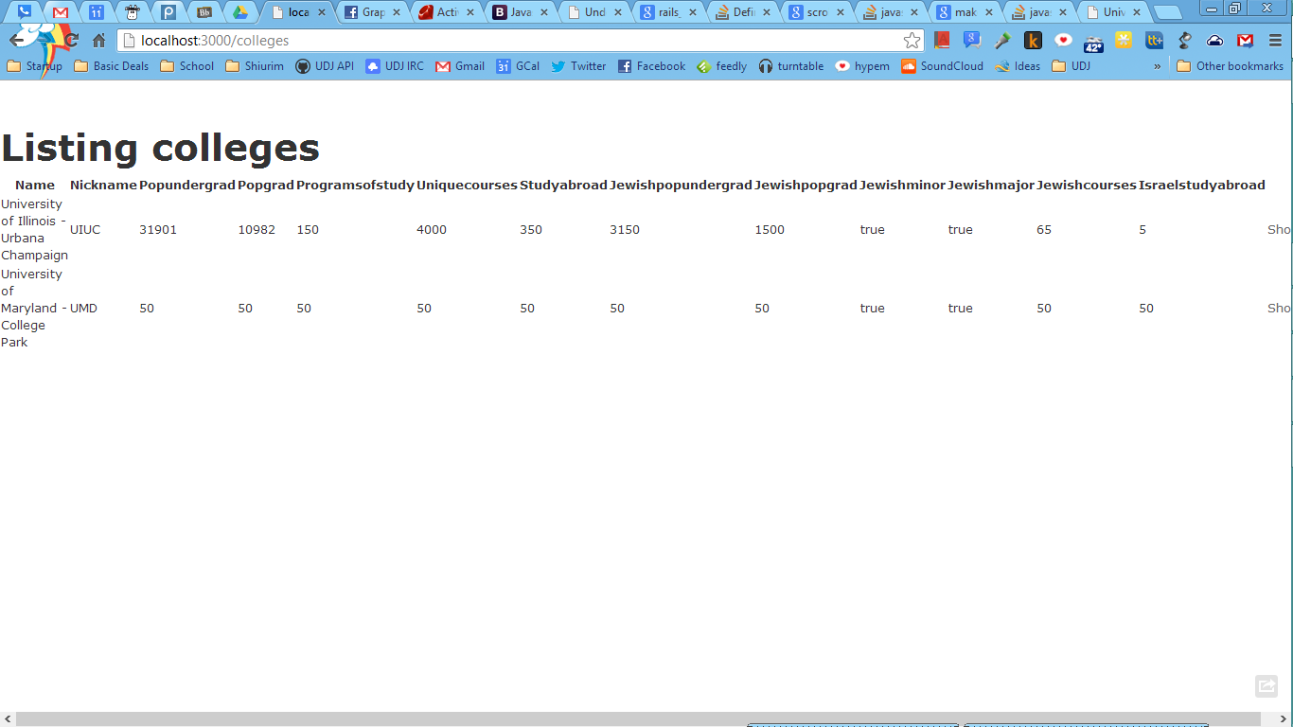

1. Type in localhost:3000/colleges/UIUC. You should see this:

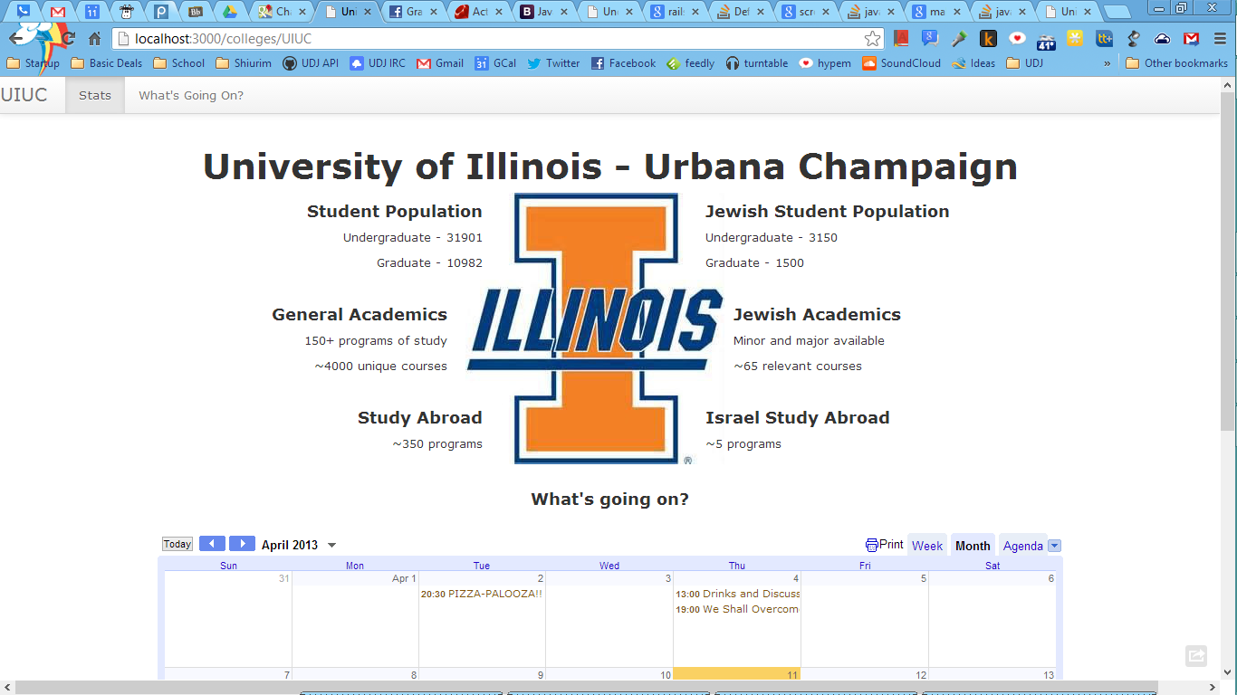

1. Ensure that as you scroll down, What’s going on becomes highlighted in the navigation bar.
2. Type in localhost:3000/colleges/UMD. You should see a similar page but with different information.
3. Make sure the calendars contain different data.
4. Go to localhost:3000/admin. Log in with [lee.mirowitz@gmail.com](mailto:lee.mirowitz@gmail.com) and 12345678. It should look like this:

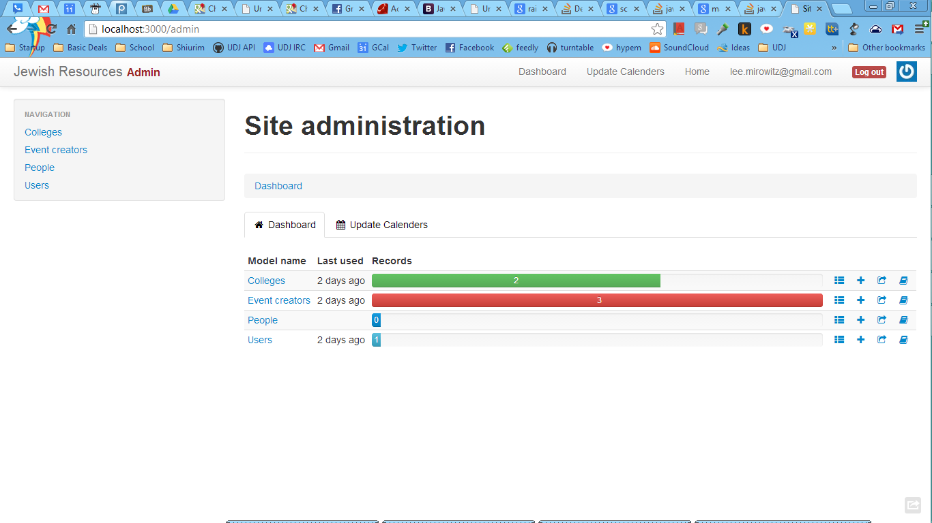

1. Click Update Calendar and make sure it’s working!
2. Click any table and make sure viewing data works!